Mid Term Report

**Project Title:** US Regional Sales Channel Prediction

# Group Details:

* Fayaz Shaik
* Mahesh Maddineni
* Nathaniel Yee
* Vivekananda Reddy Pyda

# Data:

**Type of Data**: The data is presented in a comma-separated values format, featuring a combination of text, dates, and numerical information.

**Dataset Information:**

There are 7992 attributes and 16 attributes.

* **OrderNumber:** A unique identifier for each order.
* **Sales Channel:** The channel through which the sale was made (In-Store, Online, Distributor, Wholesale).
* **WarehouseCode:** Code representing the warehouse involved in the order.
* **ProcuredDate:** Date when the products were procured.
* **OrderDate:** Date when the order was placed.
* **ShipDate:** Date when the order was shipped.
* **DeliveryDate:** Date when the order was delivered.
* **SalesTeamID:** Identifier for the sales team involved.
* **CustomerID:** Identifier for the customer.
* **StoreID:** Identifier for the store.
* **ProductID:** Identifier for the product.
* **Order Quantity:** Quantity of products ordered.
* **Discount Applied:** Applied discount for the order.
* **Unit Cost:** Cost of a single unit of the product.
* **Unit Price:** Price at which the product was sold.

Below is the information of column names and their data types.

|  |  |
| --- | --- |
| **Column Name** | **Data Type** |
| OrderNumber | object |
| Sales Channel | object |
| WarehouseCode | object |
| ProcuredDate | object |
| OrderDate | object |
| ShipDate | object |
| DeliveryDate | object |
| CurrencyCode | object |
| _SalesTeamID | int64 |
| _CustomerID | int64 |
| _StoreID | int64 |
| _ProductID | int64 |
| Order Quantity | int64 |
| Discount Applied | float64 |
| Unit Cost | object |
| Unit Price | object |

**Data Processing:**

Below are steps processing steps:

1. Checked for missing data, duplicate data. There are no such kind of data.

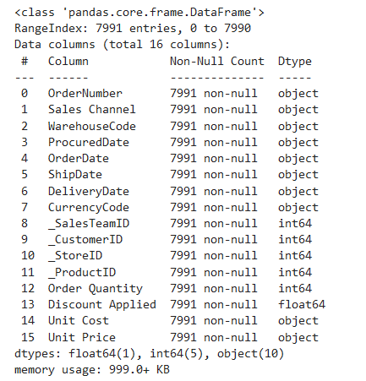



1. Converted object data type in OrderDate, ShipDate, DeliveryDate to datetime data type and also converted object data type of Unit Cost, Unit Price to float data type.
2. Derived new features “DaysToShip”, “DaysToDeliver” using OrderDate, ShipDate, Delivery date and also derived Profit using Unit Cost, Unit Price.
3. A total of 19 plots were created for the purpose of data visualization, all of which are available for reference in the attached notebook.
4. Employed encoding techniques to translate categorical values into their corresponding numeric representations.
5. Employed box plots to detect outliers within the data and subsequently removed these outliers using the Interquartile Range (IQR) method.
6. Computed a correlation matrix and created visualizations to identify the features that exhibit significant correlations with the target variable.
7. Split the dataset into training and testing sets, adhering to an 80:20 ratio.

**Which attributes you use and which one you don’t use? Why?**

* Dropped OrderNumber as it is unique for every column.
* Dropped ProcuredDate is manufacturing date of the product which doesnot require to predict sales channel
* Dropped CurrencyCode is USD for all orders and it is also not affecting our target data.
* Dropped OrderDate, ShipDate, DeliveryDate as we derived new features DaysToShip and DaysToDeliver.
* Using all other columns in the dataset including the derived features.

# Data Mining Task

**Task:** We explored 3 different multi-class classification algorithms to address the problem, given the limited unique values in the target variable. The prominent algorithms include K-Nearest Neighbors, Decision Tree, Random Forest.

Progress:

We have implemented 3 algorithms on our data after pre-processing:

* Random Forest Classification
* Decision Tree Classification
* K Nearest Neighbors Classification

**Preliminary Results:**

1. Random Forest Classification:

* Accuracy: 0.96
* Precision: 0.96
* Recall: 0.95
* F1 Score: 0.95
* Confusion Matrix:

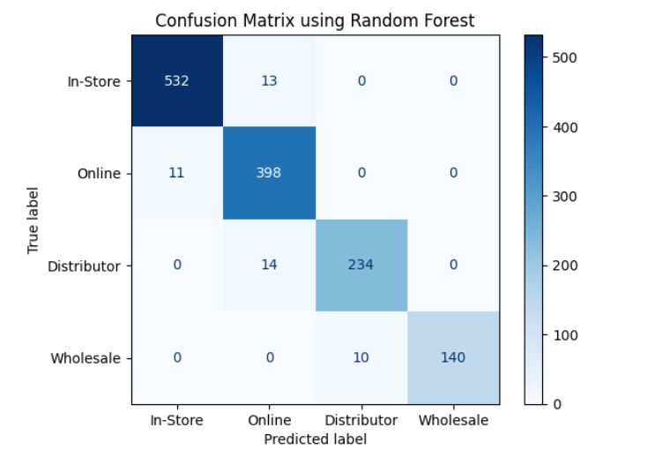

1. Decision Tree Classification:

* Accuracy: 97
* Precision: 97
* Recall: 95
* F1 Score: 96
* Confusion Matrix:

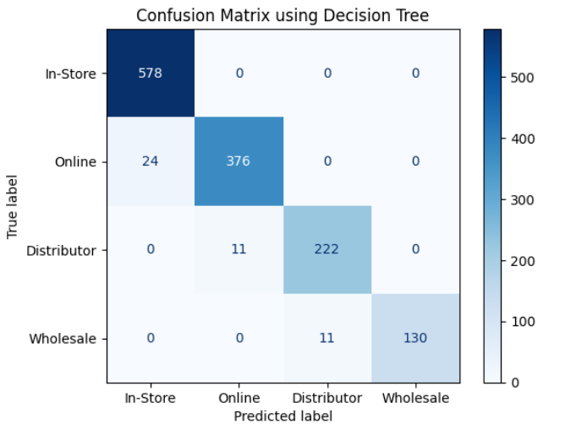

1. K Nearest Neighbors Classification:

* Accuracy: 0.92
* Precision: 0.91
* Recall: 0.91
* F1 Score: 0.91
* Confusion Matrix:

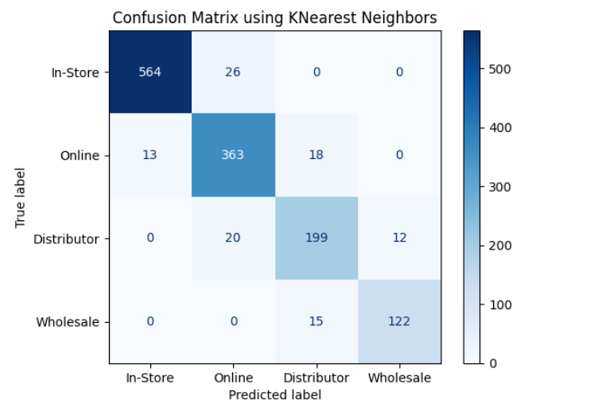

# Schedule:

* Use other classification Models (23rd Oct – 29th Oct)
* Tuning Classification Models (30th Oct – 5th Nov)
* Final Testing and Validation (6th Nov – 12th Nov)
* Presentation Preparation (13th Nov – 26th Nov)
* Project Presentation (27th Nov)